Jose Matias

in collaboration with:

Adriaen Verheyleweghen

Johannes Jäschke

Julio Oliveira

Ketil Helland

Mikael Hammer

|  |  |  |  |  |
| --- | --- | --- | --- | --- |
| EROSION RIG | | | | |
|  |  | | |  |
| SUBPRO | | | | |
|  | | Manual |  | |

TABLE OF CONTENTS

Introduction 3

1. Flowsheets and layouts 4

2. Equipment 9

3. Operation 14

4. Labview-Matlab Interface 27

5. Risk Assessment 32

Contact:

Jose Matias [jose.o.a.matias@ntnu.no](mailto:jose.o.a.matias@ntnu.no)

Johannes Jäschke [johannes.jaschke@ntnu.no](mailto:johannes.jaschke@ntnu.no)

# Introduction

**Using real-time data to support accurate decision-making on optimization and maintenance**

There is an intuitive trade-off between optimizing production and minimizing equipment degradation. In oil wells, for example, we would like to extract as much oil as possible. However, such strategy has a negative effect on the remaining useful life of the equipment. Choke valves tend to degrade faster if we increase the throughput, for instance.

In the SUBPRO center, we proposed a robust model predictive control approach that incorporates degradation models in order to balance both objectives. The main idea is to proactively control the system degradation, rather than simply reacting to it, while optimizing production. By applying our strategy, we not only enhance operational performance but also prevent violation of health-critical constraints and improve planning of maintenance activities.

**Setting up an experimental rig to validate our method**

The experimental rig described in this manual was built in order to verify the proposed controller strategy in a more realistic environment. It emulates a 3-well network in which a mixture of water and air flows through an intrusive probe that represents the choke valves. After developing a reliable model for the remaining useful life of the probes, our control strategy can be implemented and tested, which is important for learning its pros and cons as well as possible implementational risks. The rig can also provide valuable data for studying how machine-learning techniques can be used to develop data-driven diagnostic and prognostic models.

Additionally, the experimental rig can be used only for production optimization experiments, without considering degradation. Real-time optimization (RTO) and economic model predictive controllers (EMPC) can be applied, for instance.

**Manual Overview**

This manual presents an overview of the rig. First the rig ***flowsheet*** and its ***layout*** are presented. Next, the rig ***equipment list*** is shown with the links for the correspondent data sheets. Then, ***operation procedures*** (start up, shut down, and emergency) are listed and the ***control/optimization interface*** is discussed, which shows how to use the *LabView* interface and how to create your own *Matlab* codes for interacting with the rig. Finally, we included the rig ***risk assessment*** for consultation.

# Flowsheets and layouts

A simple diagram of one of the wells (the three wells are identical) can be seen below:

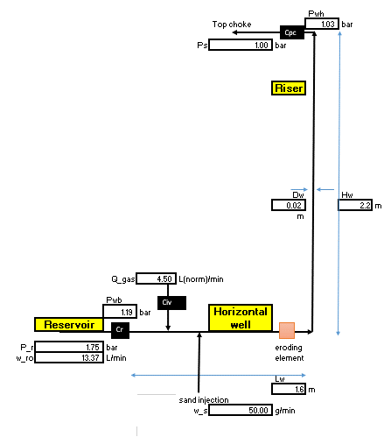

The system is divided in three subsystems:

1. ***Reservoir***: the reservoir is composed by a centrifugal pump and a control valve. By changing the valve opening and the pump rotation, we are able to freely adjust the reservoir pressure $P_{r}$ and flow rate $w_{ro}$.
2. ***Horizontal well:*** In the horizontal well the air $Q_{gas}$ and the sand $w_{s}$ are added to the system. It also contains the eroding element, which will be explained in detail later.
3. ***Riser:*** The vertical part of the well. After the eroding element, it goes up to the top chokes and the air /water separator (not shown in the diagram).

**For the calculations of nominal flowrates and pressure drop as well as the equipment dimensioning, check the folder *Excel Model* or** [here](http://folk.ntnu.no/joseoa/Laboratory/Excel%20Model/)**. The system nominal conditions are:**

|  |  |  |  |  |
| --- | --- | --- | --- | --- |
|  | min | nominal | max |  |
| Qwater | 5 | 13 | 20 | L/min/well |
| 15 | 39 | 60 | total |
| Qair | 3 | 4.5 | 6 | Lnorm/min/well |
| 9 | 13.5 | 18 | total |
| Qsand | 0 | 50 | 200 | g/min/well |
| 0 | 150 | 600 | total |
| Pressure | 0 | 0.75 | 1.1 | barg |

|  |  |  |  |
| --- | --- | --- | --- |
| Well length | | 1,6 | m |
| Riser length | | 2,2 | m |
| Pipe diameter | reservoir | 20 | mm |
| well | 40 | mm |

The rig can be seen in the picture below, where we indicate the three subsystems:

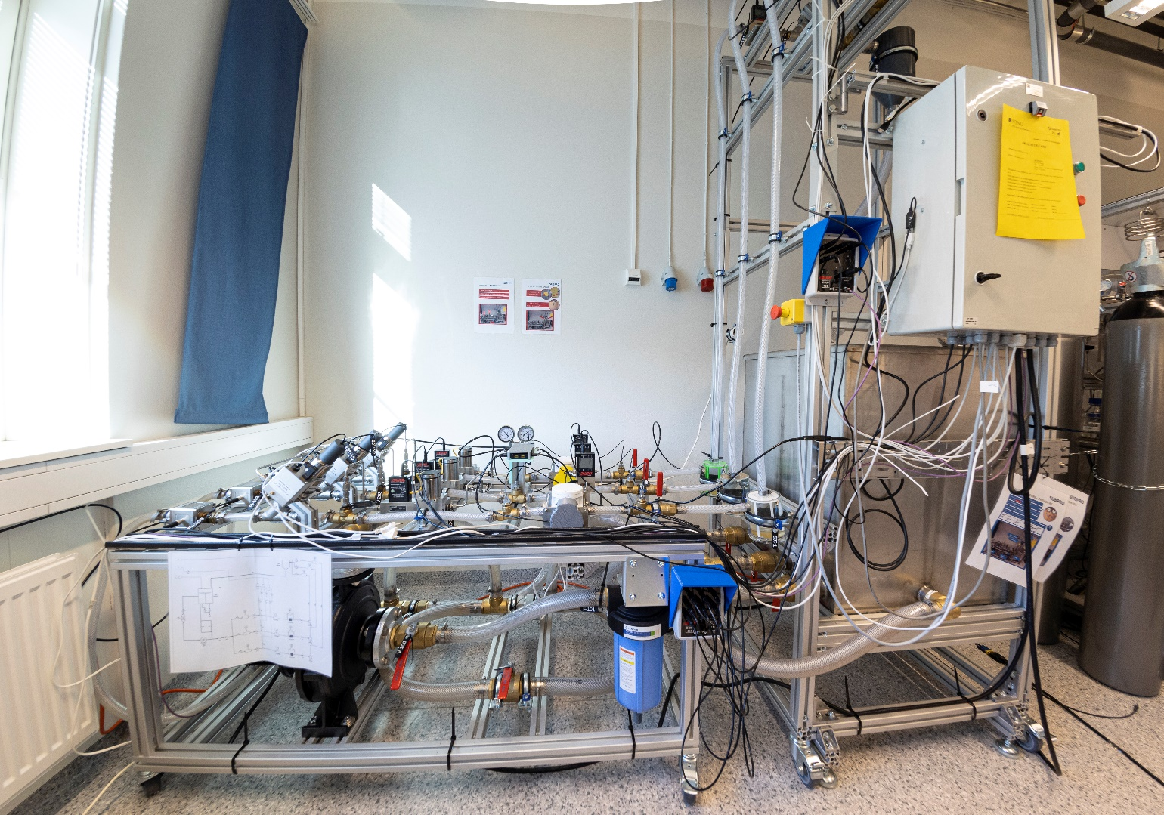

***Riser***

***Horizontal well***

***Reservoir***

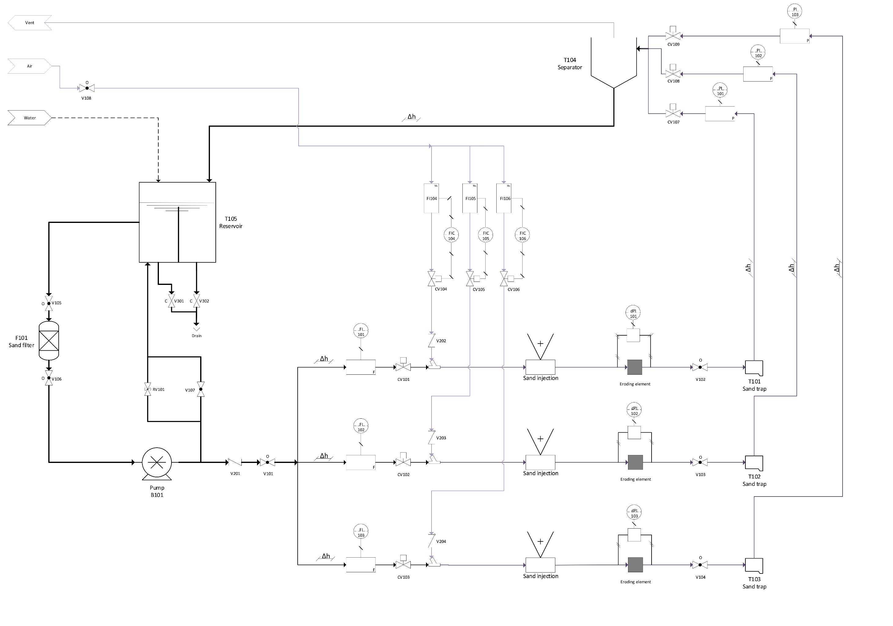

**System Flowsheet**

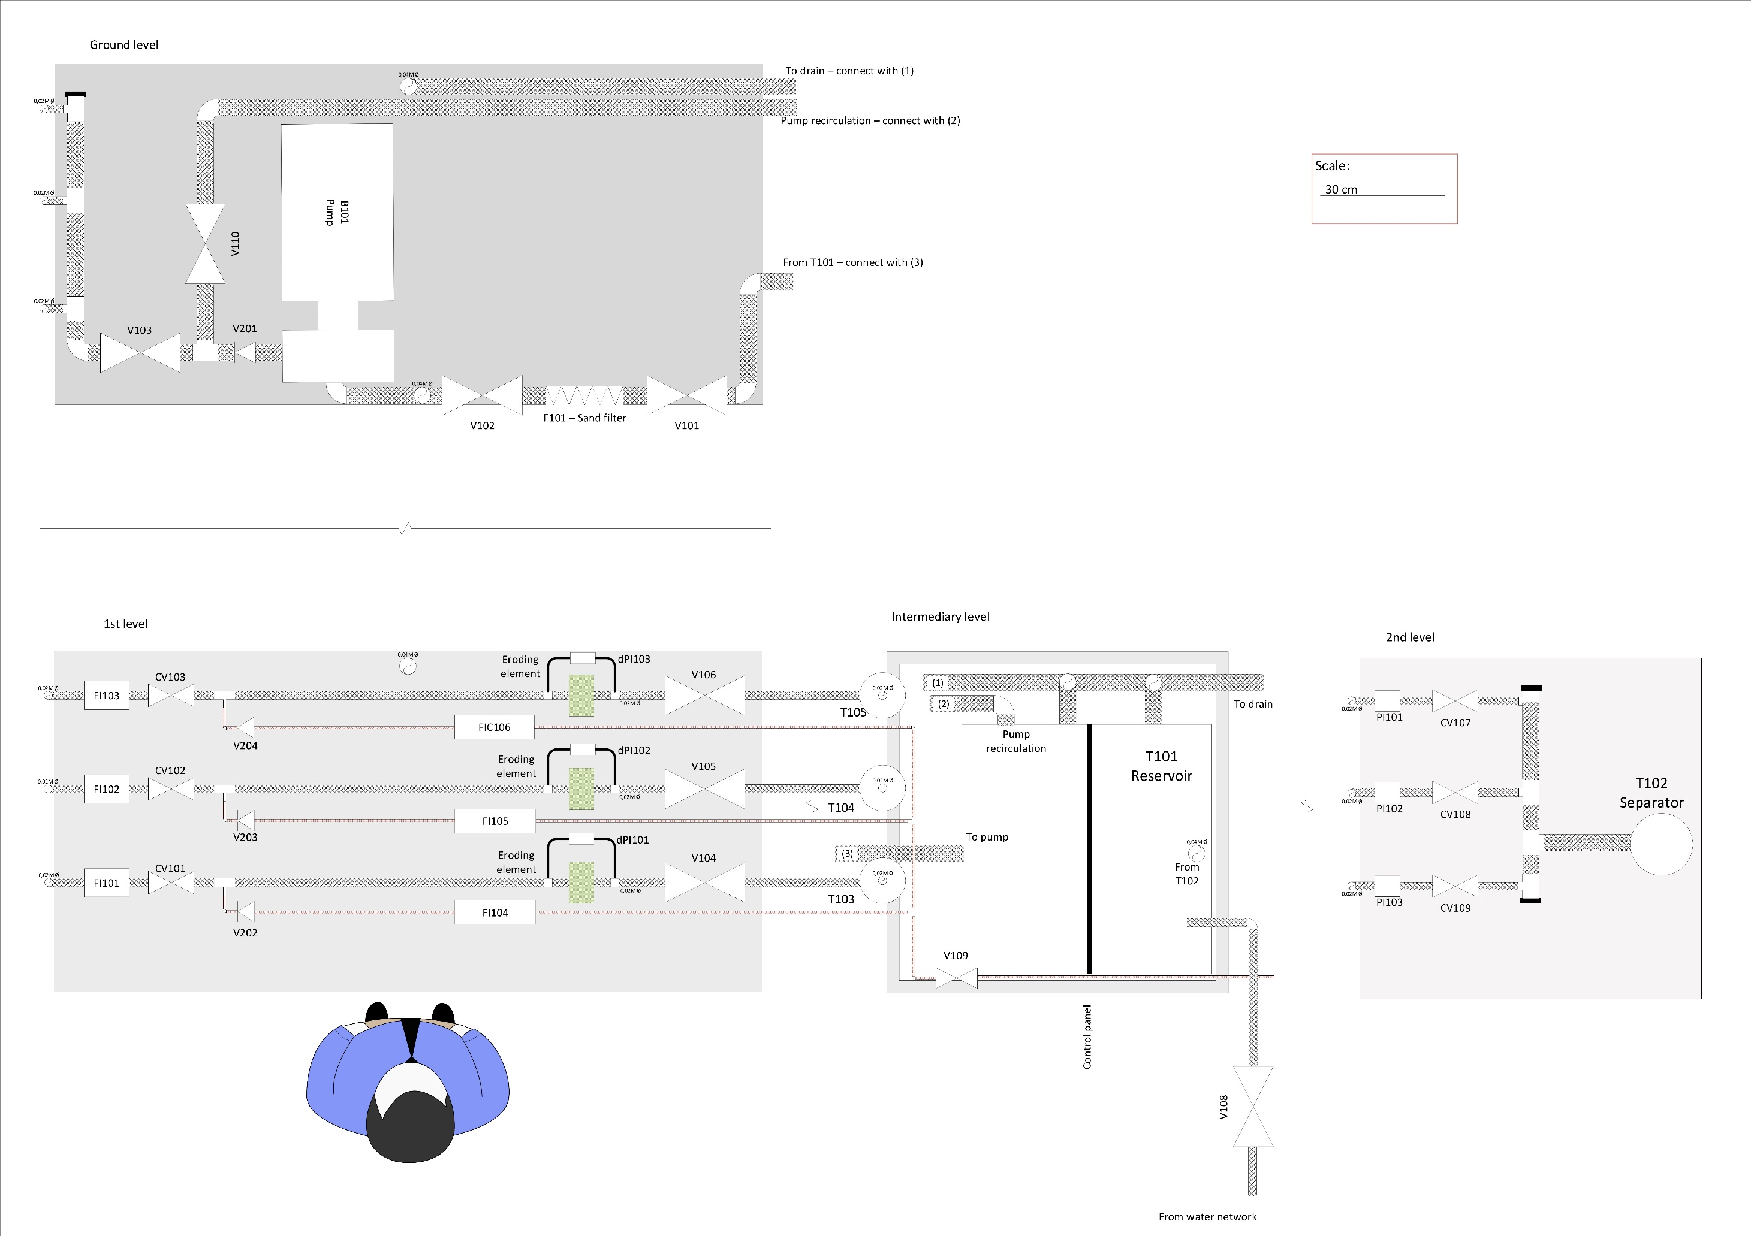

**System upper view**

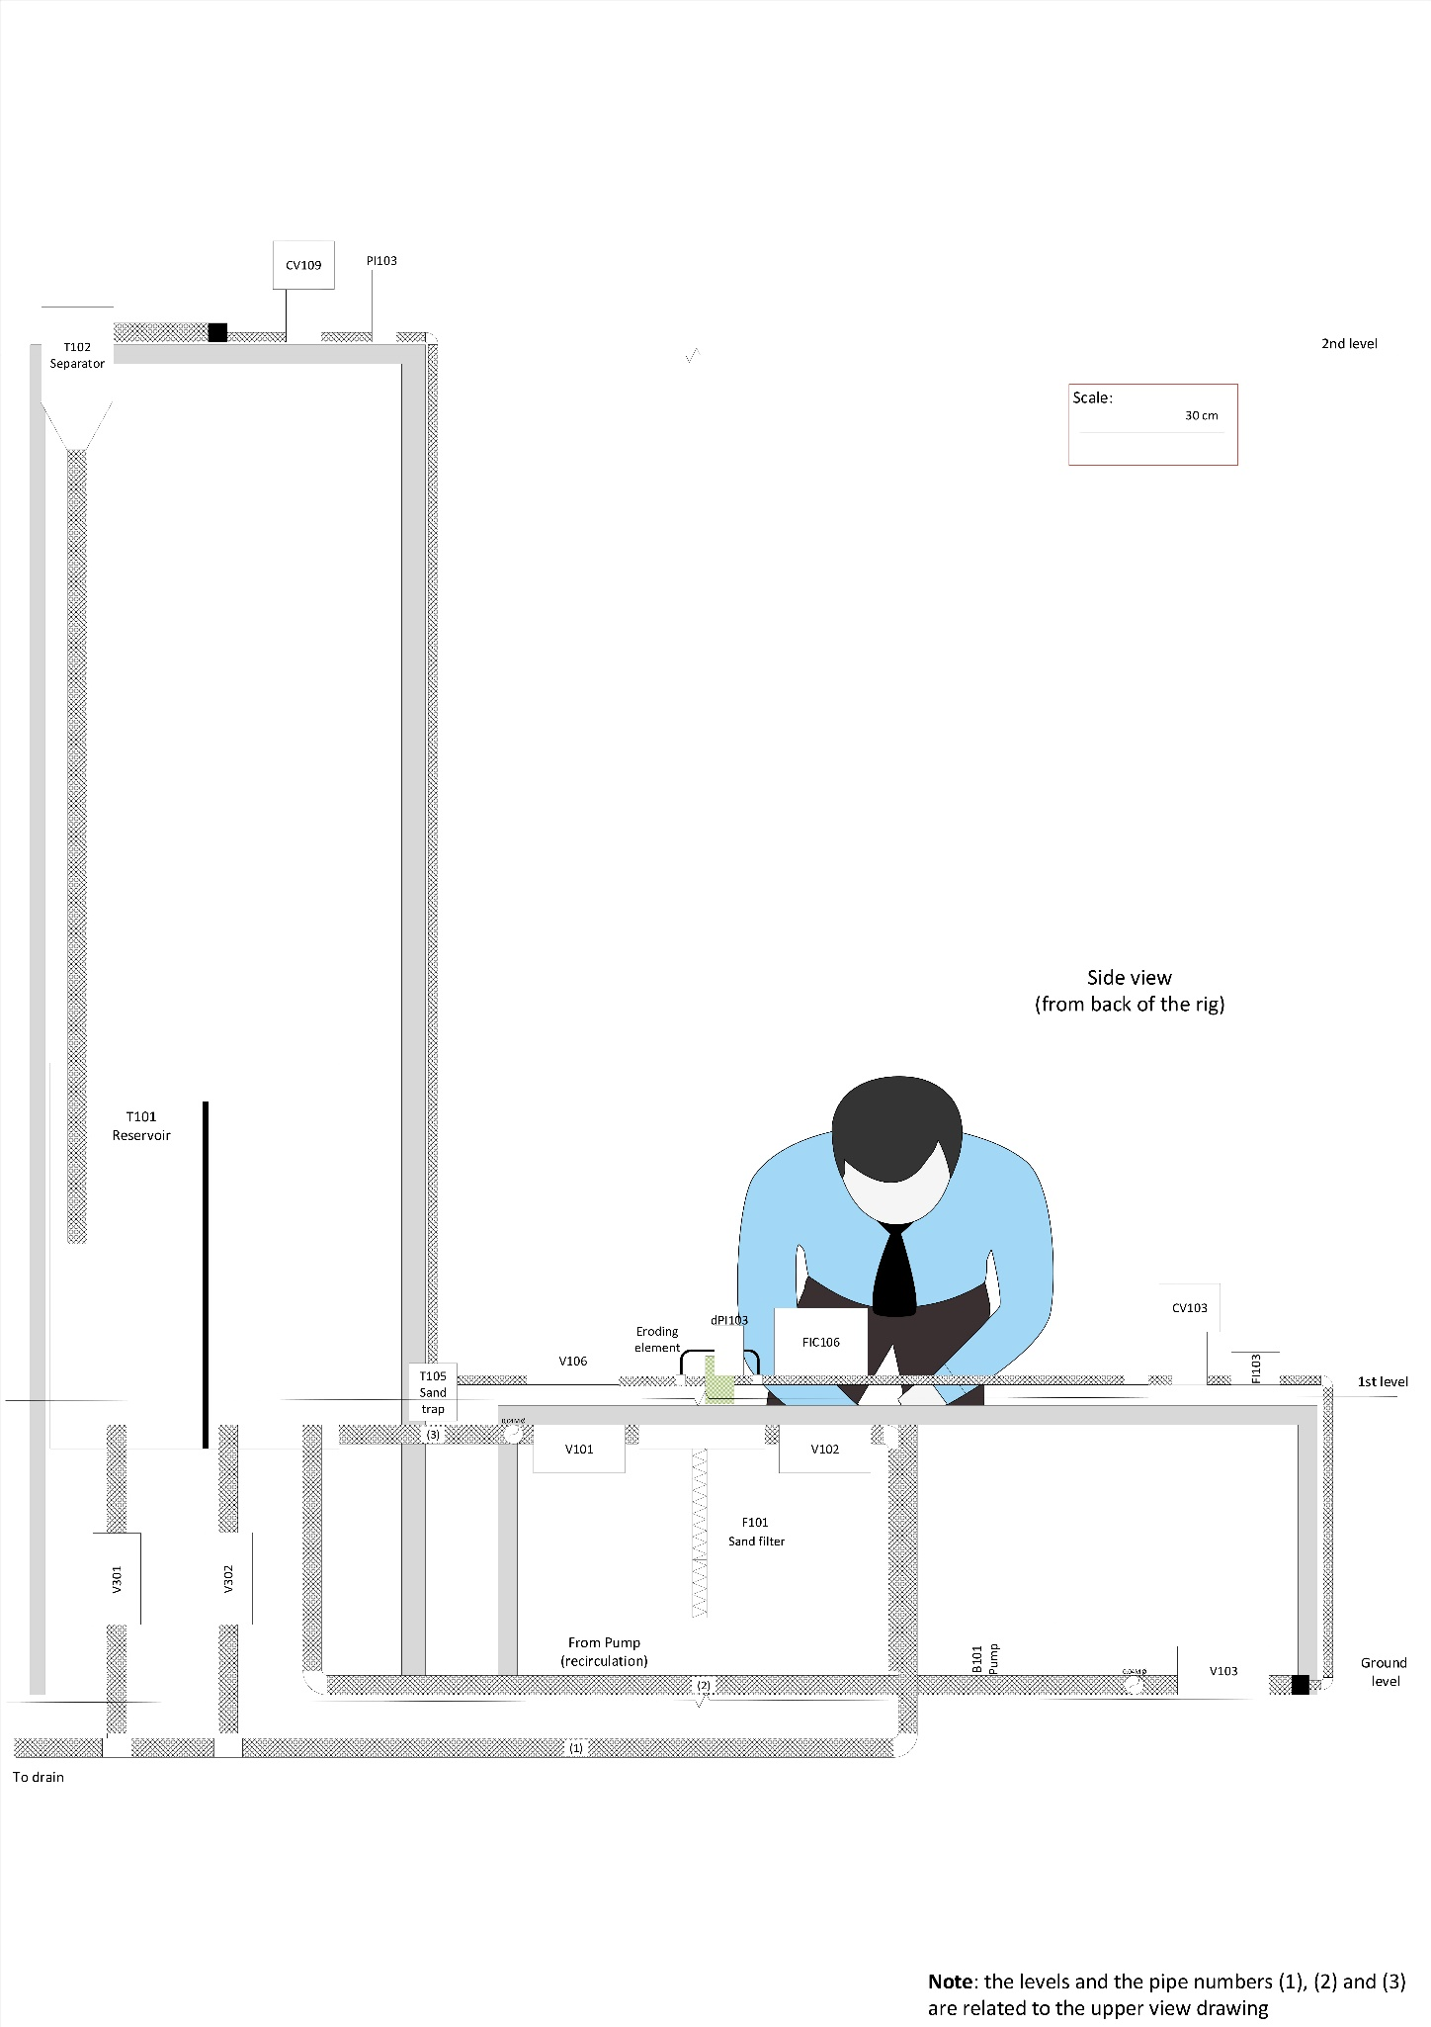

**System side view**

# Equipment

The equipment list is:

|  |  |  |  |
| --- | --- | --- | --- |
| NAME | TAG | DESCRIPTION | DOCUMENTATION |
| Pump | B101 | Centrifugal pump with speed control | [Pump_Information_Sheet.pdf](http://folk.ntnu.no/joseoa/Laboratory/Equipment/B101/) |
| Flow meters | FI102-FI103 | Flow meters (can measure temperature also) | [Flow Indicator Data Sheet.pdf](http://folk.ntnu.no/joseoa/Laboratory/Equipment/FI101_103/) |
| Control valves | CV101-106 | Proportional pneumatic valve with stem scraper | [Control Valve Specs.pdf](http://folk.ntnu.no/joseoa/Laboratory/Equipment/CV101_106/) |
| Pressure meters | dP101-103 | Differential pressure meters for the Erosion Box. They are the same as the pressure meters (PI101-103), but installed in a different way (i.e. they can be converted in pressure meters if necessary) | [dPressure Gauge Data Sheet.pdf](http://folk.ntnu.no/joseoa/Laboratory/Equipment/dP101_103/) |
| Sand traps | T101-103 | Designed to avoid clogging of the riser by sand. Based on water well sand traps. The material is transparent acrylic and the bottom can be opened for cleaning. They were produced in the Fine Mechanics Workshop in NTNU. | [Tank Sketch.pdf](http://folk.ntnu.no/joseoa/Laboratory/Equipment/T101_103/) |
| Pressure meters | P101-103 | Pressure meters. See dP101-103 | [Pressure Gauge Data Sheet.pdf](http://folk.ntnu.no/joseoa/Laboratory/Equipment/PI101_103/) |
| Top separator | T104 | A cylindrical tank made of PVC for air/water separation. It was produced in the Fine Mechanics Workshop in NTNU. | [Tank_Sketch.pdf](http://folk.ntnu.no/joseoa/Laboratory/Equipment/T104/) |
| Reservoir | T105 | Stainless steel tank for storing water that is recycled to the system by the pump. The tank has an internal baffle that divides the tank in two chambers. The idea is to keep the sand in the first chamber while the water overflows the baffle to the second chamber, which is connected to the pump suction. | [Tank_Information.pdf](http://folk.ntnu.no/joseoa/Laboratory/Equipment/T105/) |
| Filter | F101 | Bag filter for protecting the pump from sand. | [Bag_Filtration – Housing.pdf](http://folk.ntnu.no/joseoa/Laboratory/Equipment/F101/) |
| Air flow controllers | FIC105-106 | Integrated flow/mass controllers | [FlowMass_Controllers_Data_sheets.pdf](http://folk.ntnu.no/joseoa/Laboratory/Equipment/FIC104_106/) |
| Cameras | n/a | Cameras for detecting the erosion | Model: [HBV-1705 S1.0](https://www.hbvcamera.com/1-3megapixel-usb-cameras/hbv-1705-s1.0.html) |
| Erosion Boxes | Frankie101-103 | 3D printed. The details for printing and assembling are given in the next section. | 3D models |

In addition to the equipment, there are several 3D printed structures that are installed in the lab. Here, we list them and link the 3D model files for printing new copies if necessary. They are all printed using PLA 2.85mm.

|  |  |  |
| --- | --- | --- |
| NAME | DESCRIPTION | FILE |
| Sand trap filters | Filter that avoids parts of the eroding probe to clog valves CV107-109. In extreme cases, It also avoids that the sample reach the pump and potentially damage it. | [3D design](http://folk.ntnu.no/joseoa/Laboratory/3D%20Design/Sand%20Trap%20Filter/3D%20Models/)  [For printing](http://folk.ntnu.no/joseoa/Laboratory/3D%20Design/Sand%20Trap%20Filter/For%20Printing/) |
| Alicat hub protector | Cover for the alicat hubs (which connect the equipment to the cabinet and the computer). It aims at avoiding water spillage on the equipment | [3D design](http://folk.ntnu.no/joseoa/Laboratory/3D%20Design/Alicat%20Hub%20Protector/3D%20Model/)  [For printing](http://folk.ntnu.no/joseoa/Laboratory/3D%20Design/Alicat%20Hub%20Protector/For%20Printing/) |
| USB cables hub protector | Supports (and protects from water spillage) the USB hub that is used for connecting the 6 cameras to the computer. | [3D design](http://folk.ntnu.no/joseoa/Laboratory/3D%20Design/USB%20Hub%20Protector/3D%20Model/)  [For printing](http://folk.ntnu.no/joseoa/Laboratory/3D%20Design/USB%20Hub%20Protector/For%20Printing/) |
| Equipment tag | Tags for the equipment | [For printing](http://folk.ntnu.no/joseoa/Laboratory/3D%20Design/Equipment%20Tag/) |

The manual valves are butterfly valves with 20mm (V102-104) and 40mm (V101, V105-107, V301-302) of internal diameter. There are also one-way valves (V201-203) for avoiding that the liquid gets in contact with the air control valves (FIC104-106). Finally, there is one pressure regulator (V108) that separates the air that goes to the pneumatic valves and to the system via the air control valves (both come from the same air source).

The pipelines are plastic hoses with internal diameters of 20mm/40mm and 1mm stainless steel tubes for the air. The frames and connections were built in the IKP Workshop at NTNU.

* Erosion box: the erosion box was designed as a chamber where we insert the probe that will degrade. We have two cameras, one on each side of the box, and a light source in the bottom in order to keep track of the probe erosion evolution.

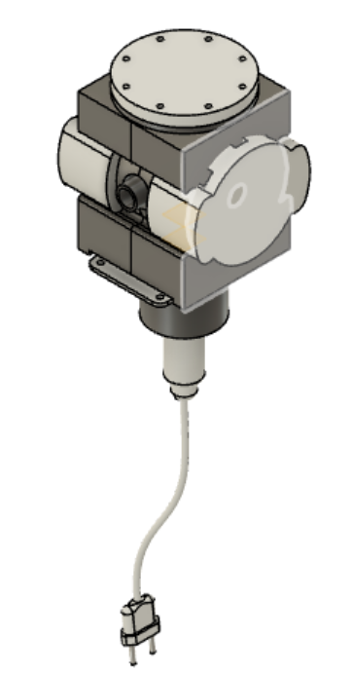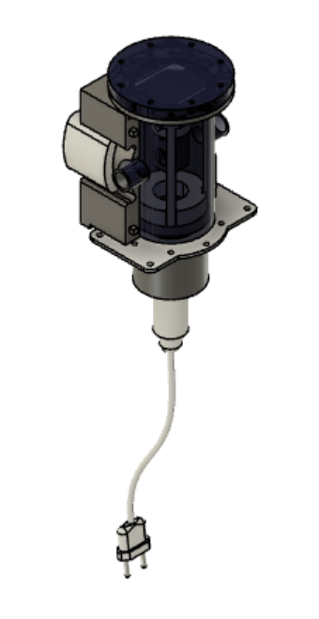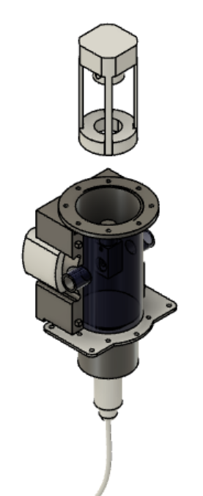

Figure : Erosion box closed (left) and opened (center). The probe support is inserted inside the Erosion box by opening the top cover (right)

The erosion box is composed by (the 3D model and the printing files can be found in the attached folders or [here](http://folk.ntnu.no/joseoa/Laboratory/3D%20Design/Erosion%20Box/):

|  |  |
| --- | --- |
| ITEM | PICTURE |
| *Acrylic tank*: The tank was designed according to the 3D model, but it was built at the Fine Mechanics Workshop in NTNU |  |
| *Metal Bracket:* This part is not 3D printed. It is made of steel and it was machined at the Fine Mechanics Workshop in NTNU. |  |
| *Side Covers:* two side covers, one is male and the other female. Printed in PLA 2.85mm with 15% of infill and layer height of 0.15mm [1] |  |
| Camera Holders (2x: Designed to fixate the cameras on the sides of the erosion boxes. Printed in PLA 2.85mm with 15% of infill and layer height of 0.15mm |  |
| *Light Holder:* Designed to fixate the cameras on the sides of the erosion boxes. Printed in PLA 2.85mm with 15% of infill and layer height of 0.15mm. |  |
| *Sample support:* Designed to hold the probe during the experiments. Printed in PLA 2.85mm with 80% of infill and layer height of 0.1mm. |  |
| *Sample support fixation:* Designed to stabilize the probe support. Printed in PLA 2.85mm with 80% of infill and layer height of 0.1mm. |  |
| *Probe support:* Designed to fixate the probe during the experiments. Printed in PLA 2.85mm with 80% of infill and layer height of 0.1mm. |  |

After printing printing all the 3D parts, they should be assembled according to the 3D model *ErosionBox2 v15.step*

* Probe: the eroding probe is also 3D printed. They are designed to match the layout of the *Master Flow* choke valves[2]

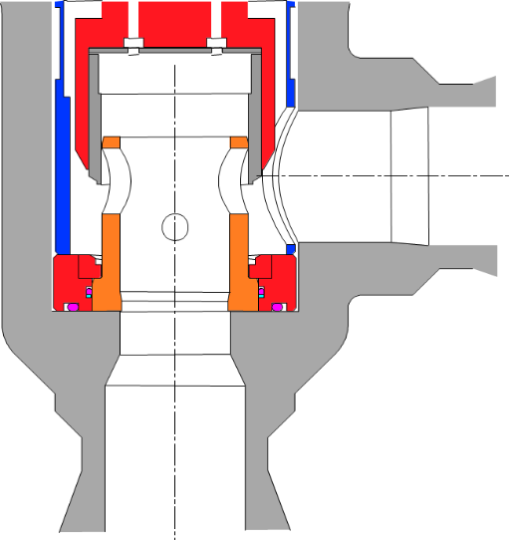 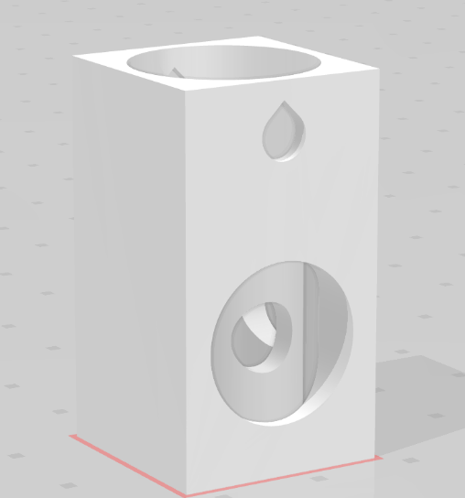

Master Flow chokes

Probe

For printing the probe, instead of using PLA, we used Poly(vinyl alcohol) (PVA), which is a water-soluble synthetic polymer. Since the probe dissolution in water is a function of the fluid bulk velocity (consequently, it depends on the liquid and gas flow rate), we can “control” its erosion rate by adjusting the flow rates. In nominal conditions, it usually takes one hour for the probe to be completely eroded.

In order to obtain standard probe infills, layer heights, etc., use the *Cura Project* in the attached folder (or [here](http://folk.ntnu.no/joseoa/Laboratory/3D%20Design/Erosion%20Box/Probe/Cura%20Project/)). Note that you also need PLA to print the probes. While the main body is made of PVA, you need PLA to create the support for printing the probe internal part.

# Operation

This section shows the operational procedures for

1. Rig start-up (general)
2. Rig shutdown (general)
3. Erosion Experiments Start-up (in addition to *Procedure 1*)
4. Camera Setting
5. Erosion Experiments Shutdown (in addition to *Procedure 2*)
6. Minor emergency (which include minor leakages, for example)
7. Major emergency (automatic rig shutdown)

In addition, we include a guide showing how to use the *Labview* interface for operating the rig.

You can find the procedures in the attached folders or [here](http://folk.ntnu.no/joseoa/Laboratory/Procedures/). There are printed copies near the rig for consultation.

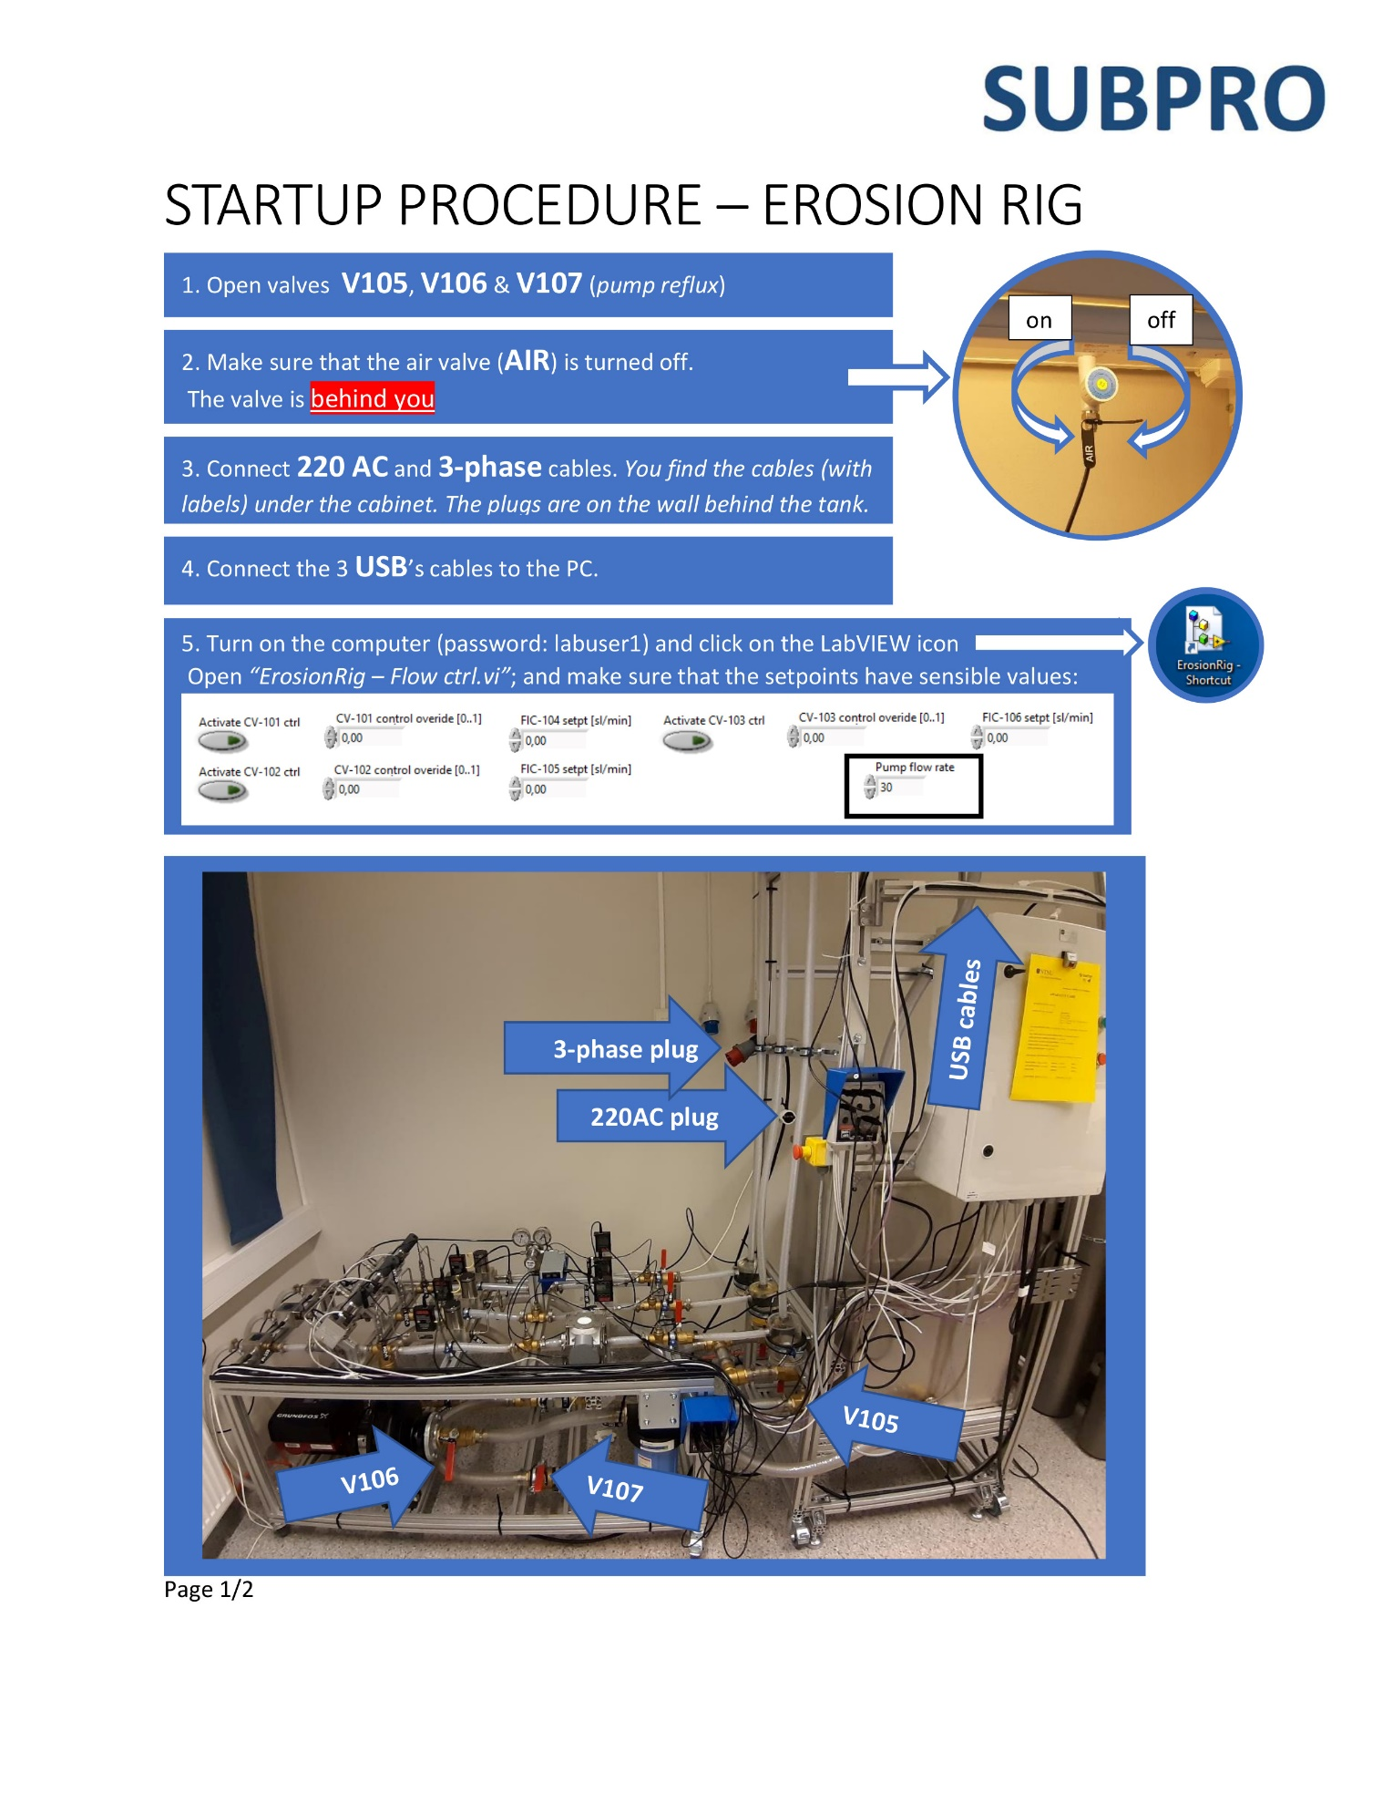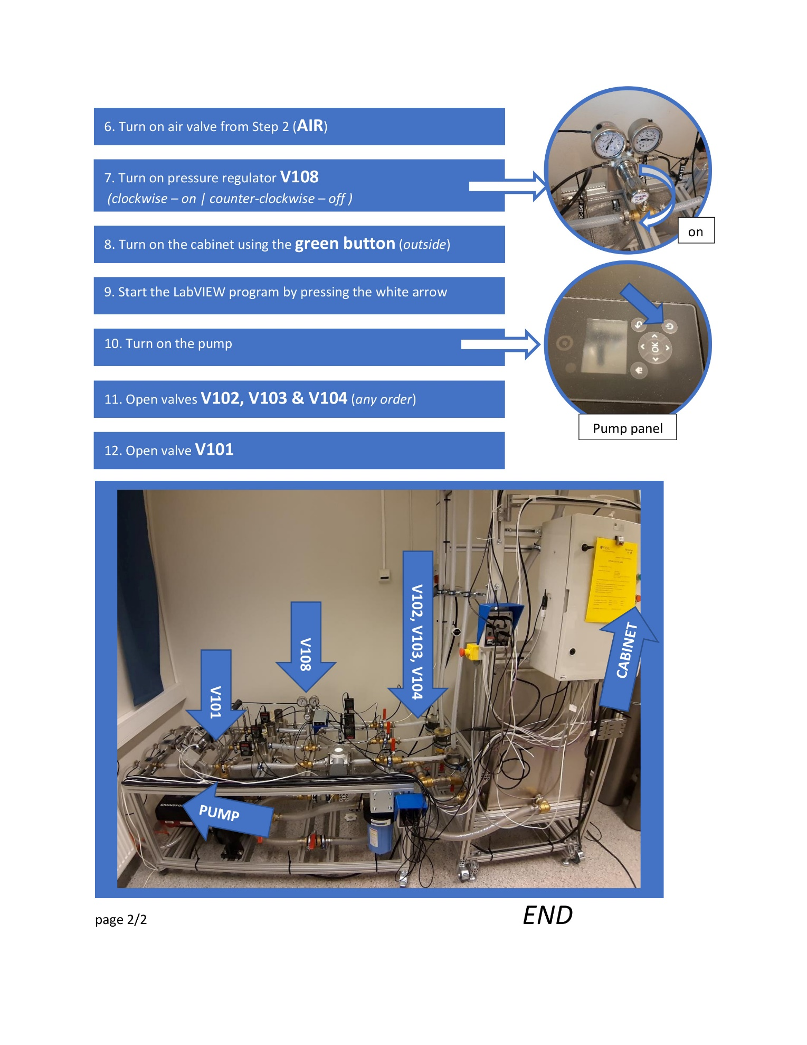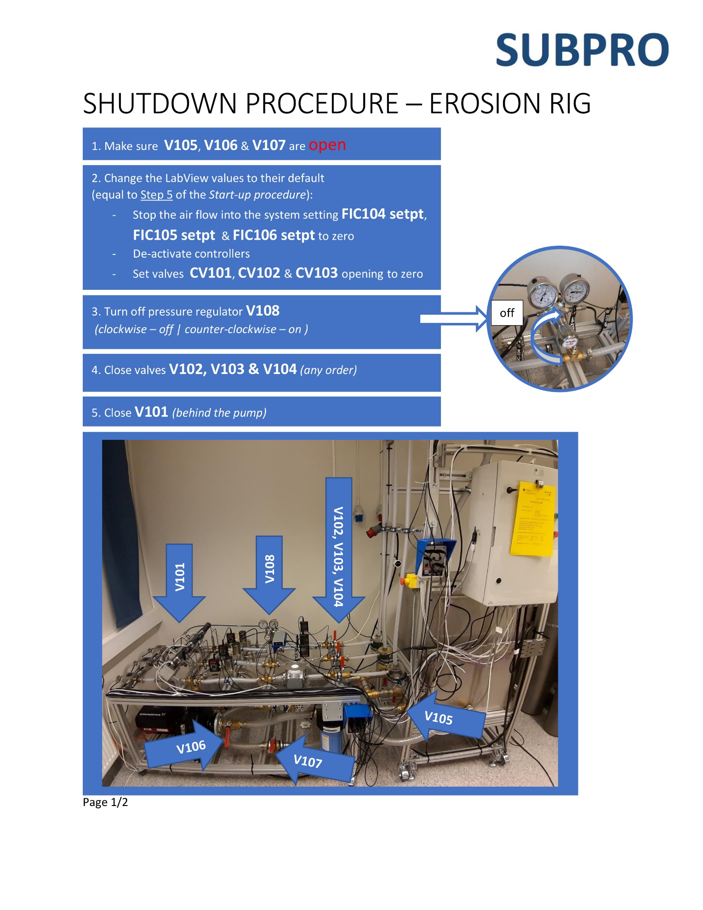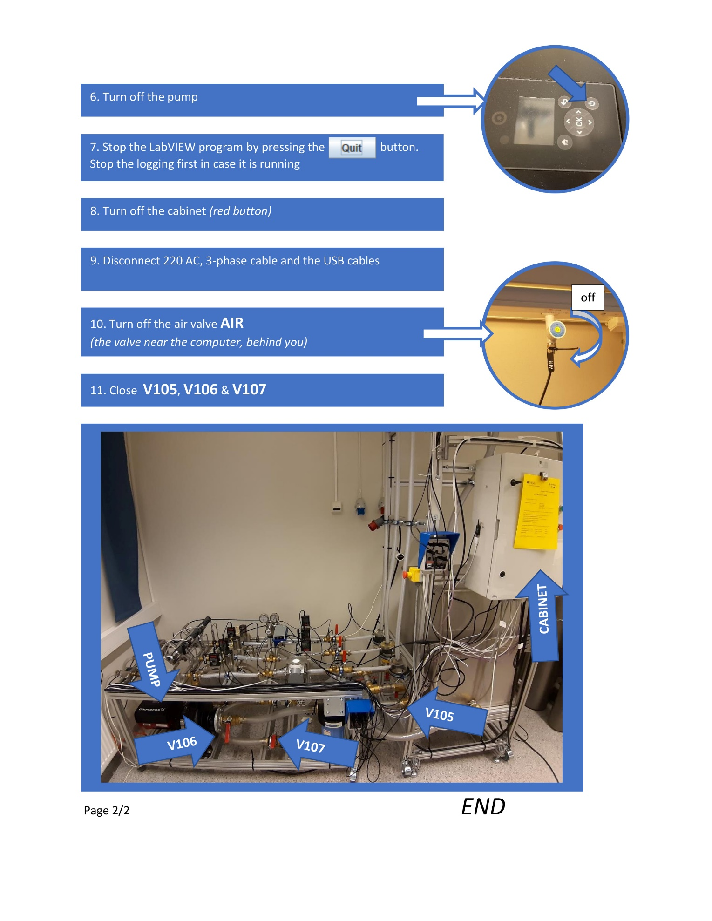

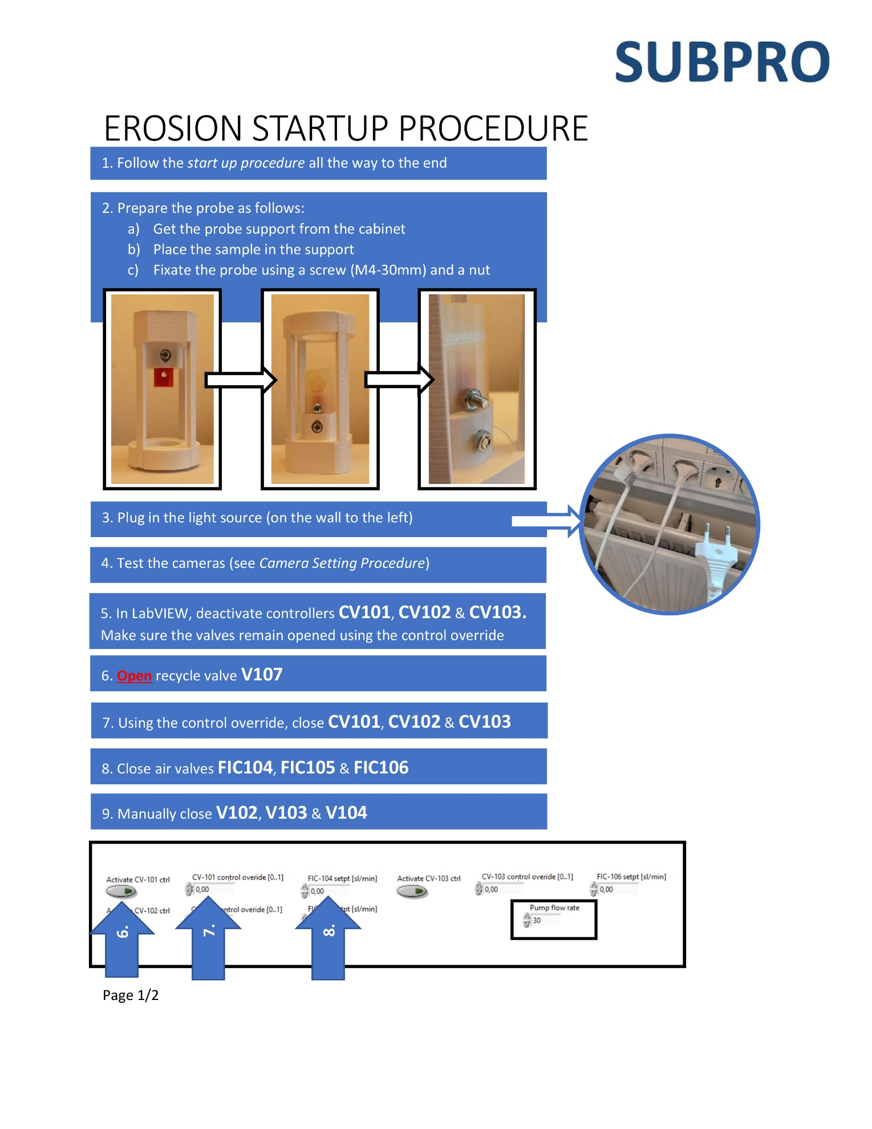

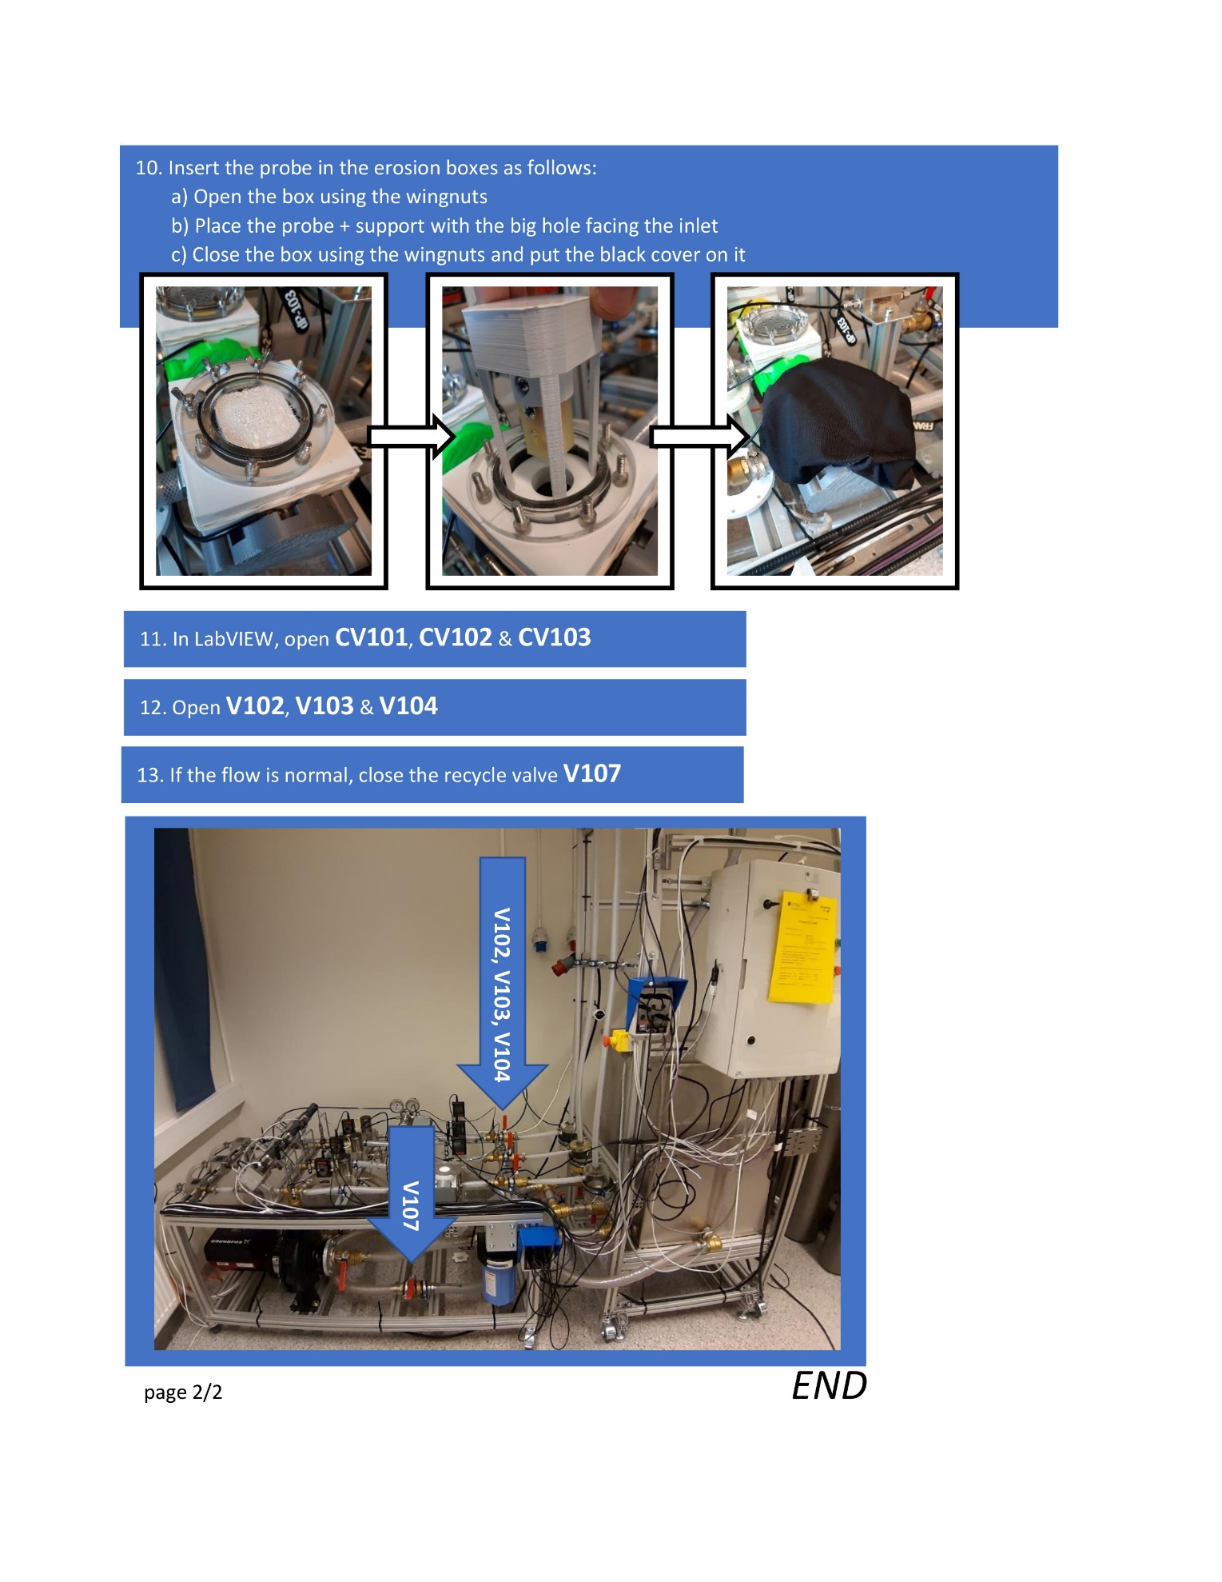

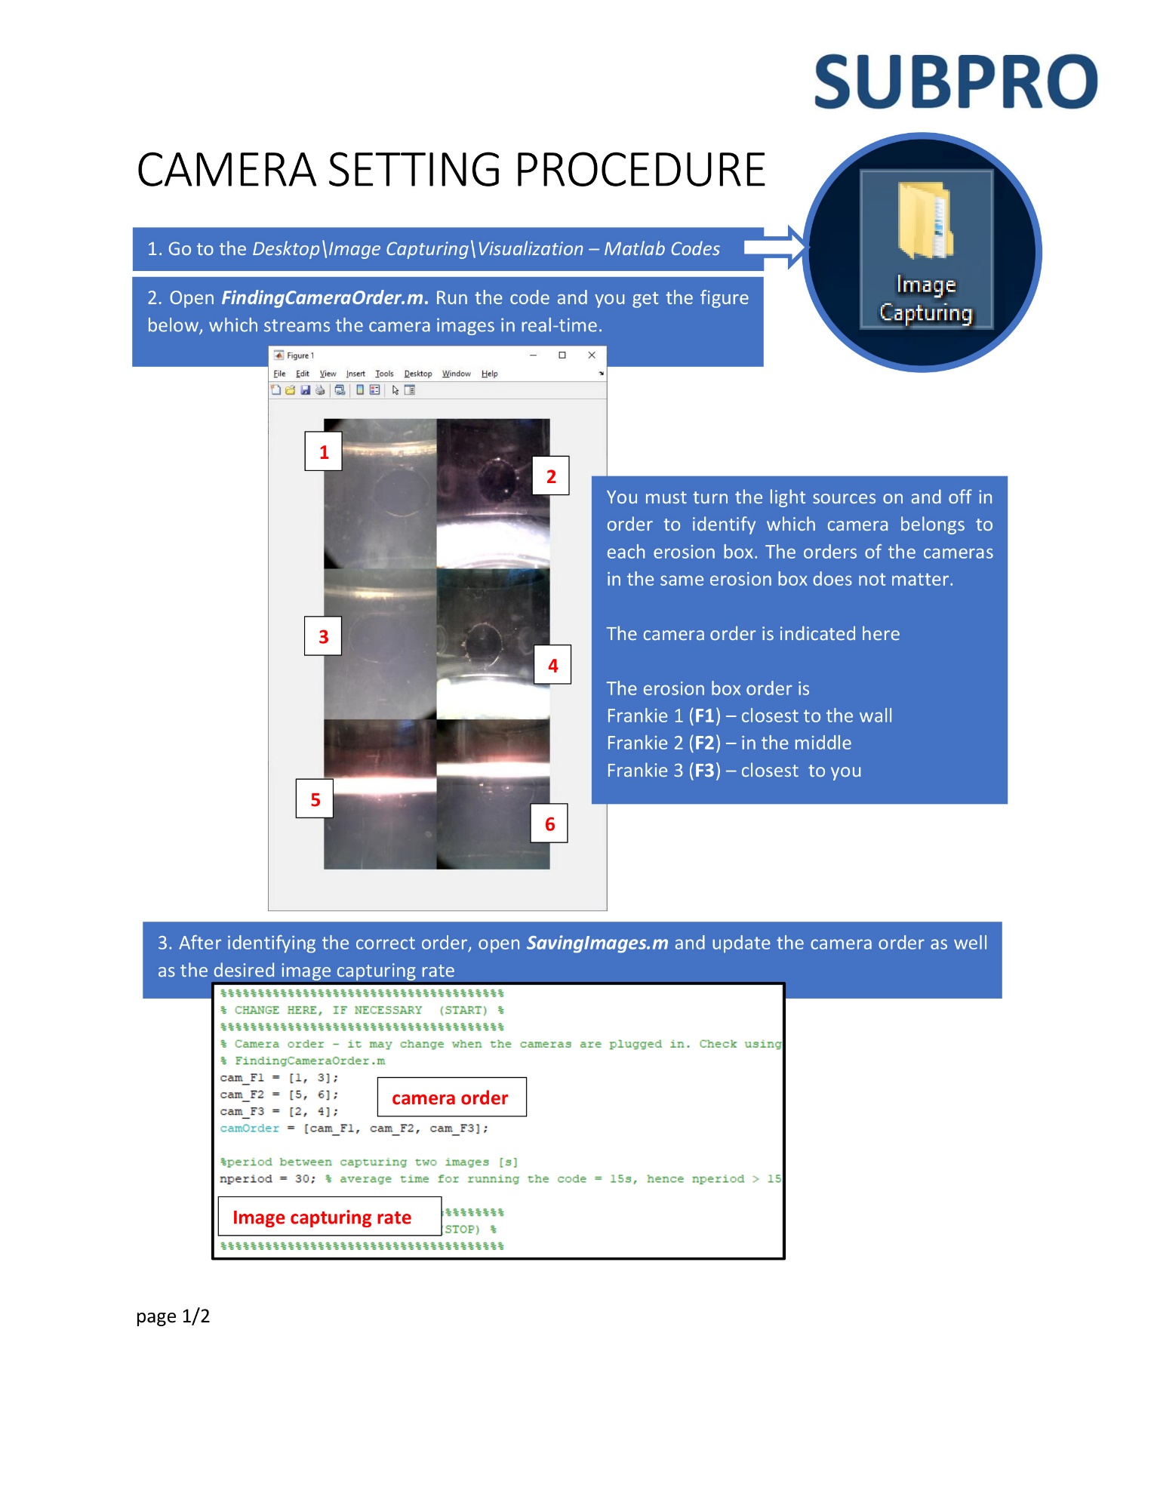

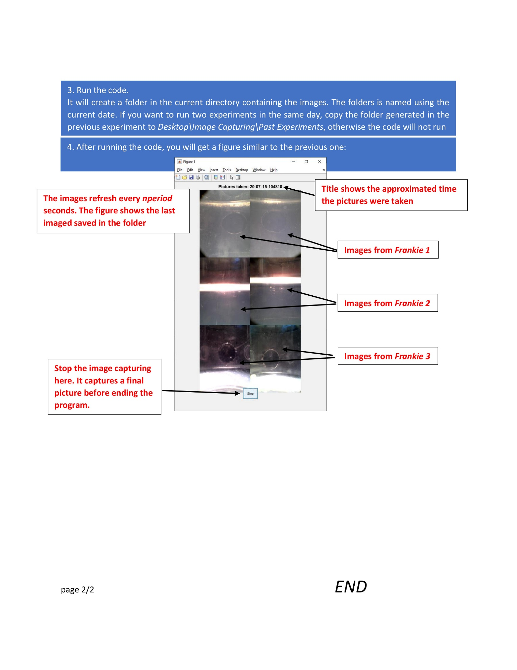

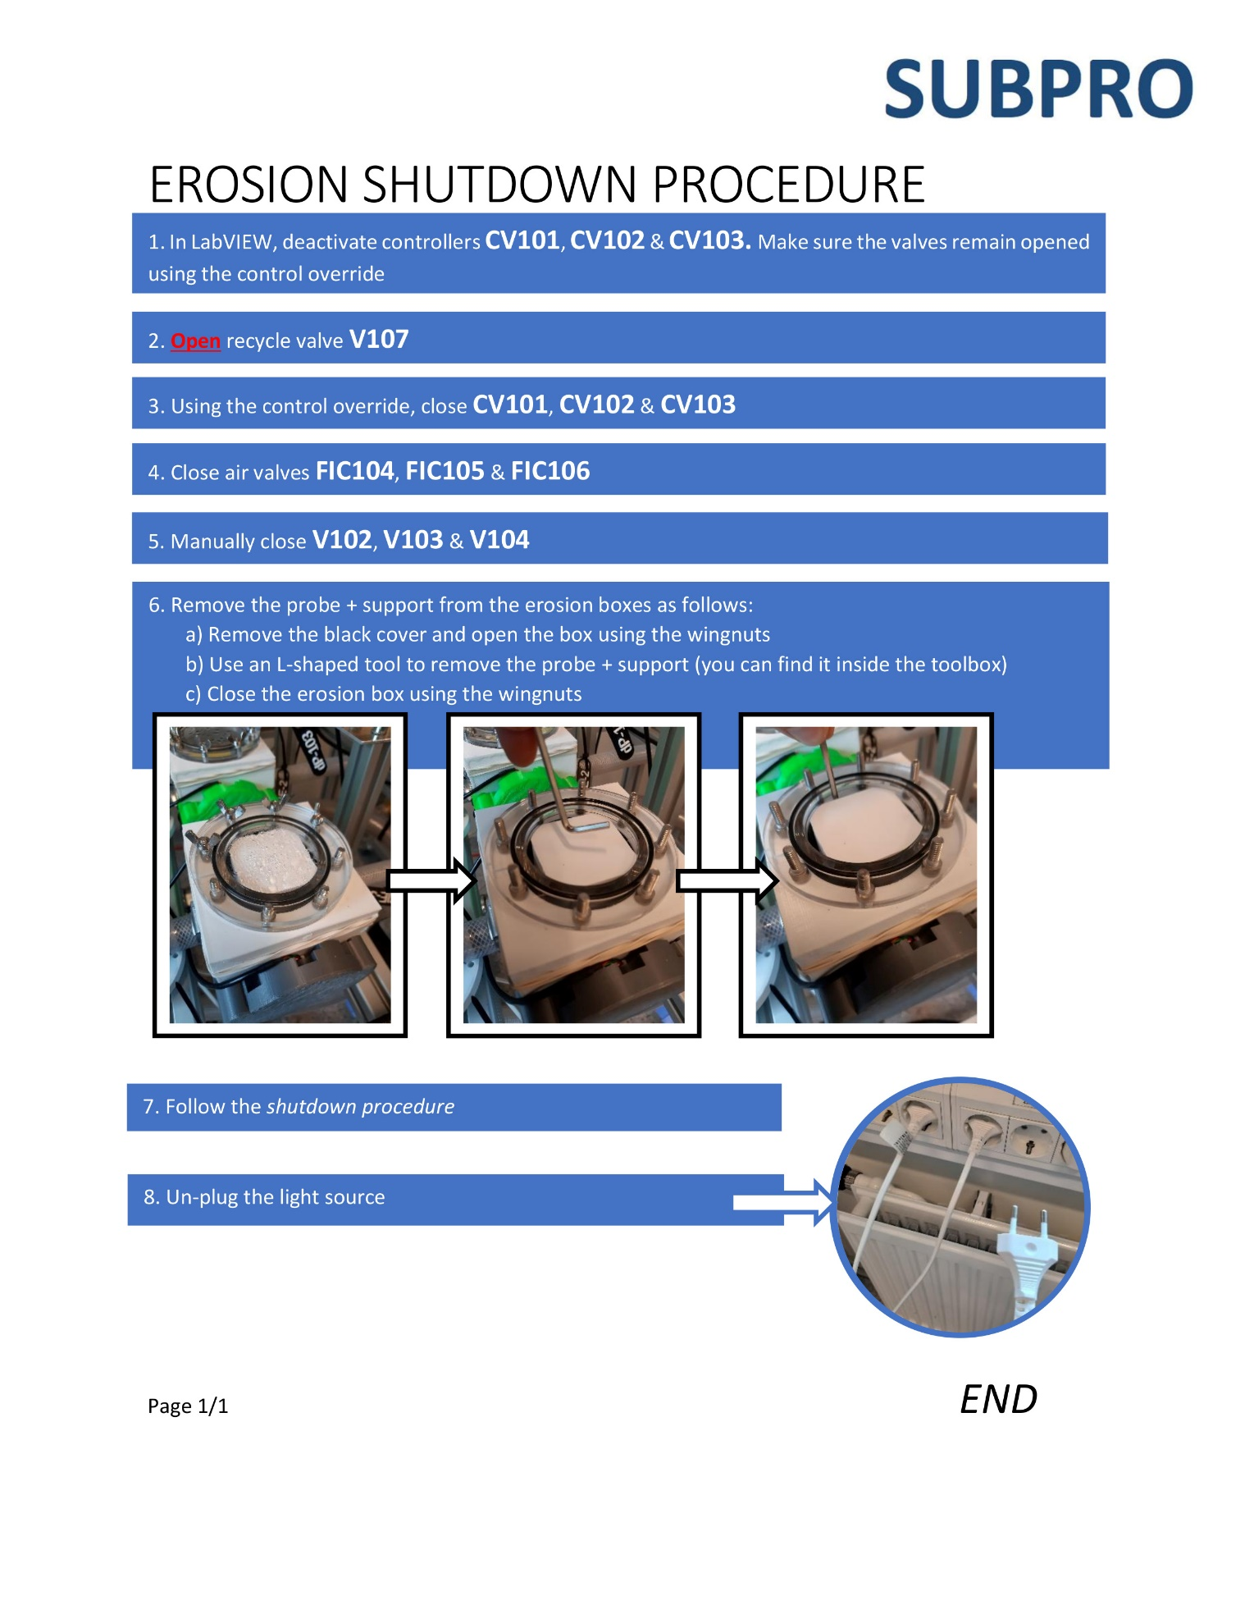

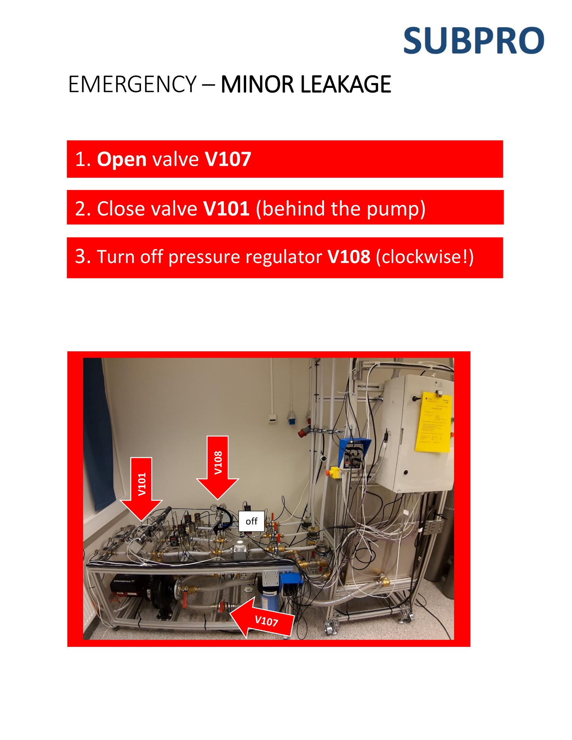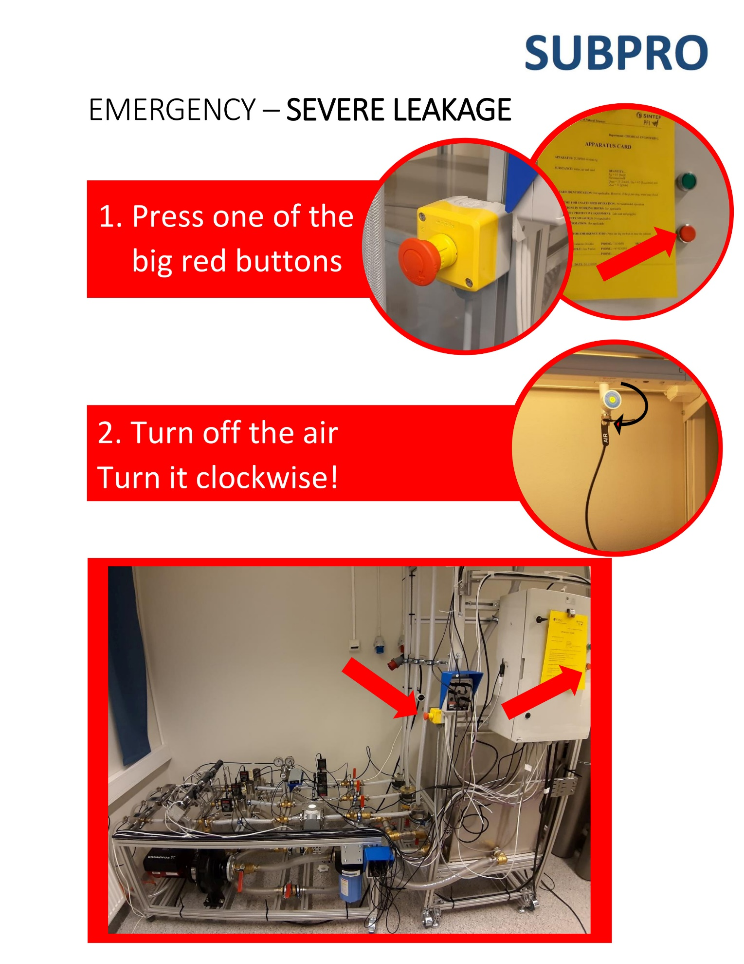

* ***Labview Interface***

The gray squares indicate the measurement values

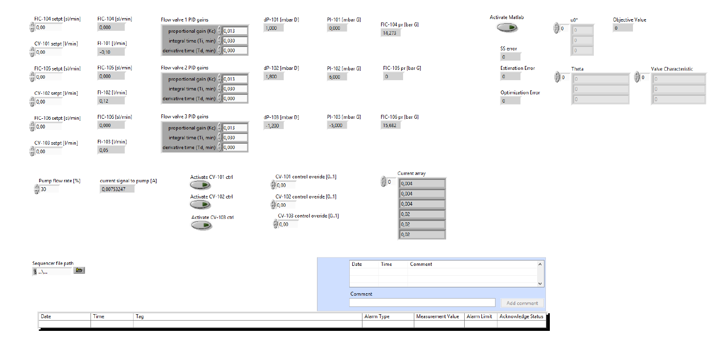

N

Air flow controllers setpoints. For the air valves, the valve/meter are integrated. You cannot operate in open loop. You can change the PID directly in the equipment. Check manual.

Pump rotation control

Min – 13% (0.004mA) | Max – 90% (0.02mA)

*The min value is fixed, but the max value can be adjusted by changing the ***pump setpoint*** directly in the pump controllers. Check pump manual

This indicates the current that goes to the valves

Closed – 0.004mA | Opened – 0.02mA

If you want to add comments to the log file, use this tab

Y

If the controllers are deactivated (N), use the override to control the valve opening. If the controllers are activated (Y), you can set the flow setpoints. You can adjust the control tuning.

Y/N?

PID controllers *CV101-103* tunning

***Add log and plot***

# Labview-Matlab Interface

After opening the *Labview* project XXXX you get to this interface. It is a little bit different from the standard one.

If you click twice on the edge of the "Activate matlab" button while the program is not running,

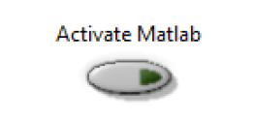

it will take you to the window shown below

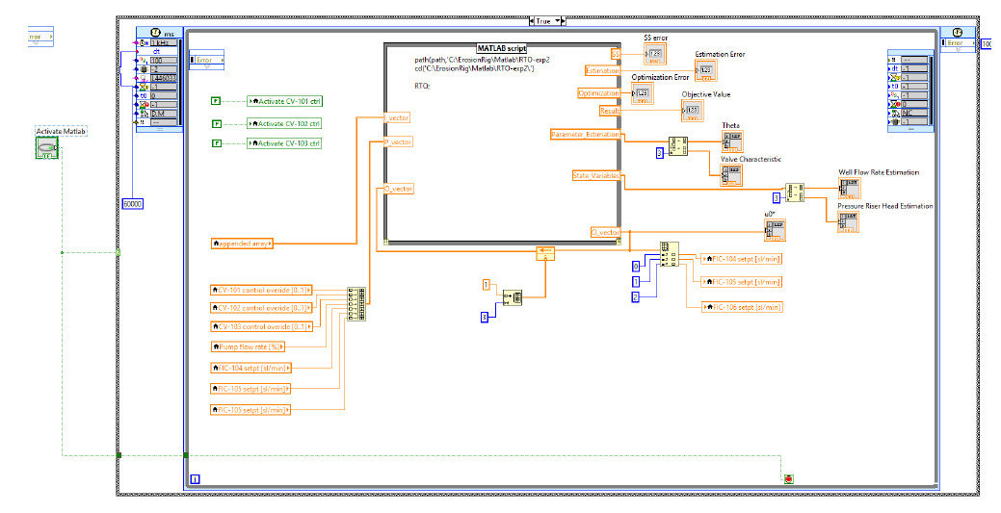In this “code” you can see a conditional structure in which the automatic settings for the valve opening are deactivated.

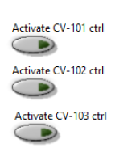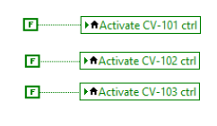The appended array

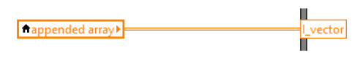

contains the experiment state measurements, this will be used as an input for the *Matlab* script as the "I vector" variable. The construction of this array can be seen below (Note that we keep track of the last 30 measurements and then allocate the measurements in the "appended array"):

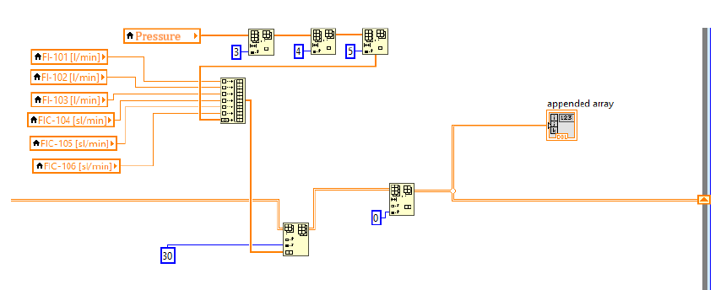

The “P_vector” contains the following variables:

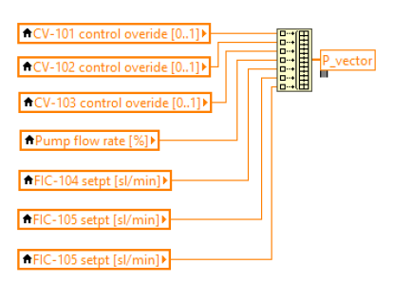

They can be changed from the main screen:

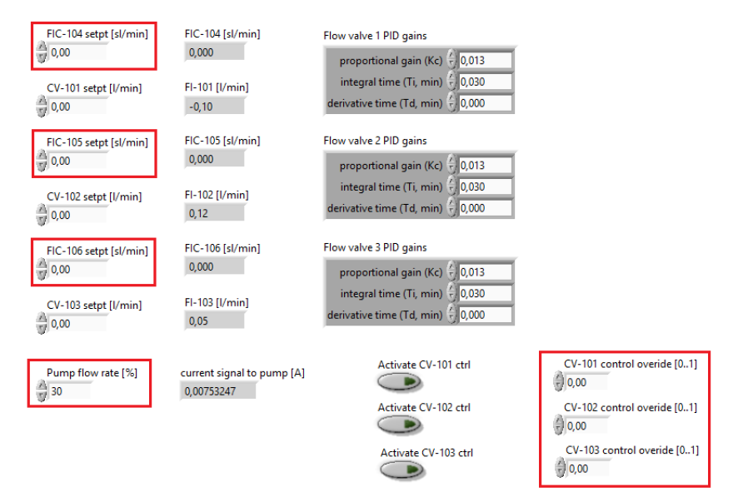

Inside the the **Matlab Script** block, there are 3 lines of code. The first line show the path to directory of the main *Matlab* program, the second give access to change the folder and the last is the optimization script.

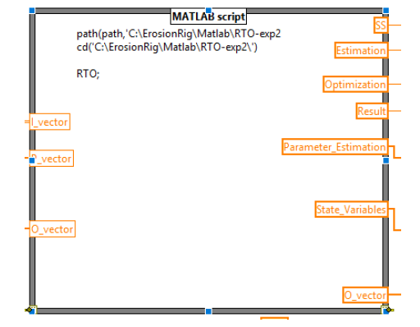

The optimization code should be divided in 3 parts. "Getting Variables", "Solving optimization" and "Sending Variables". A pseudo *Matlab* code can be found in the attached folders (or here).The connection between the *Matlab* script and *Labview* is shown below. Note that, in this example, we send a given set of variables to the *Labview* interface (SS, Estimation, Optimization, Result, Parameter_Estimation, State_Variables, O_vector), this set can be changed according to what is going on the optimization code.

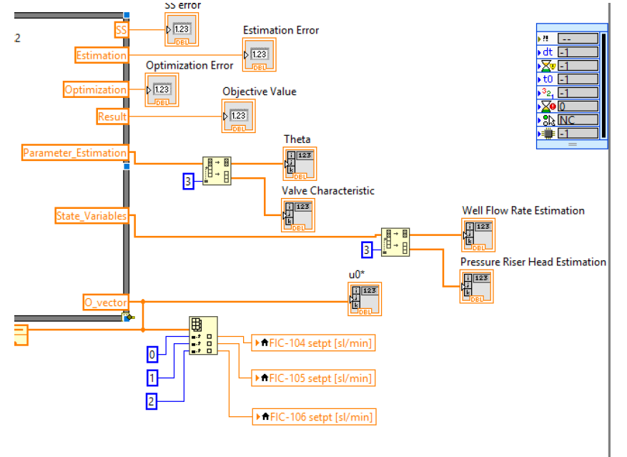

The values sent to the interface can be seen on the main screen. If you change them, you also have to adapt the main screen indicators accordingly.

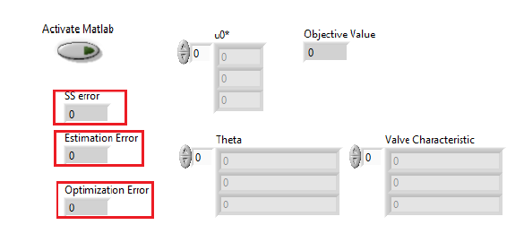

The vector “O_vector” contains the optimized values of the gas flow rates. It is attached to an indicator, but also it feedbacks to the input, if you need access to the previous values (e.g. in real-time optimization (RTO), you can compare the previous value of the optimized gas flow rates with the computed one in order to decide if you update them or not). In addition, the values from “O_vector” are sent to the *Labview* parameter settings FICsetpoint-104/105/106 automatically.

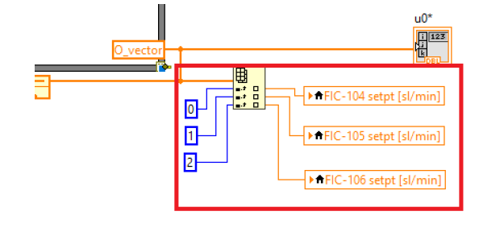

Finally, the optimization code is set to run every 60 seconds (or 60000ms), but that can be adapt if necessary by changing the timer parameter

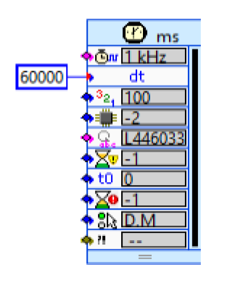

# Risk Assessment

In this section we show a simplified risk assessment of the rig. First, we list the existing measures. Then, we show the incident/hazards that may happen, their consequences, and which measure apply.

* ***Existing measures:***

|  |  |  |
| --- | --- | --- |
| # | EXISTING MEASURES | DESCRIPTION |
| 1 | **PPE** | For operating the rig, the only necessary PPE is the lab googles. If you want to protect your clothes from getting wet, you should also use a lab coat. Gloves and masks are not necessary |
| 2 | **Recycle valve (V107)** | This is the most important valve during the operation. Identify it before running the rig. It is easy to access it and right in front of the rig on the ground level |
| 3 | **System feed valve (V101)** | This valve is the most difficult one to access. It is behind the pump. If necessary, one have to go behind the rig to open/close it. |
| 4 | **Pressure regular (V108)** | Valve with two pressure indicators. The air that comes from the lab compressor is used both in the pneumatic valves and as the system air (feed to valves FIC104-106). |
| 5 | **Cloths** | In the drawers that are cloths for drying the floor |
| 6 | **Drain in the floor** | The drain is located near the eye shower. If you are using the drain valves V301-302, you should open the drain using and put the pipe inside of it. Otherwise, the water will overflow. |
| 7 | **Shut-off button** | Big red button. You can use the cabinet red button. |
| 8 | **System air feed (valve under the cabinet)** | Blue valve under the cabinet (see the procedures in the previous sections) |
| 9 | **Antifoaming agent** | CHECK WHICH ONE. Using for avoiding foam created by stirring the mixture of water and diluted PVA |
| 10 | **Sand protective equipment** | Filter F101, Sand traps and internal baffle of T105 |
| 11 | **Sand trap filters** | 3D printed filters that are placed inside the sand traps. |
| 12 | **Labview Interface** | Easily control the valve openings and pump rotation |

* Incident/hazard likelihood:

|  |  |  |
| --- | --- | --- |
| Unlikely *(once every six months)* | Likely *(once in a month)* | Very likely *(daily)* |

* **Consequences**

|  |  |  |
| --- | --- | --- |
| Small  *(operational shutdown – turn of the rig. No need to contact others)* | Large  *(shutdown for more than 3 weeks – need to contact NTNU workshops)* | Very large  *(shutdown for more than 3 months – need to contact external vendors)* |

Risk analysis with evaluation of likelihood and consequence

|  |  |
| --- | --- |
| Blocking the pump | |
| RIKS/HAZARD  LIKELIHOOD | **Measure:** Recycle valve (V107) |
| Due to some reason, one close the valves after the pump and does not turn the pump off. Pressure will start to build up and may damage equipment, specially pipes and pipe connection.  If the recycle valve remains closed, there is a relief valve (RV101) that opens when pressure is larger than 3 bar, which avoids damaging the main |
| CONSEQUENCES |
| Minor leakage | |
| RIKS/HAZARD  LIKELIHOOD | **Measure:** Recycle (V107), system feed (V101) valves and pressure regular (V108) |
| Small leakages in the pipes and connections. Follow the minor leakage procedure.  Very likely when installing new equipment |
| CONSEQUENCES |
| Major leakage | |
| RIKS/HAZARD  LIKELIHOOD | **Measure:** Shut-off bottom and system air feed |
| If several liters of water leak on the floor, it may damage the electrical equipment leading to a shutdown. It may also flood the floor and affect the other rigs in the room as well as the laboratory downstairs. Follow the major leakage procedure. |
| CONSEQUENCES |
| Pipes/valves clogging | |
| RIKS/HAZARD  LIKELIHOOD | **Measure:** Recycle (V107) and system feed (V101) valves, shut-off bottom, drain on the floor, sand protective equipment, and sand trap filters |
| The pipes/valves may clog due to sand accumulation and if the probe gets loose. Since we operate with three wells in parallel, it is unlikely that the three wells get clogged at the same time. For the feed and recycle lines, the sand protective measures and the sand trap filters were designed in order to avoid pipe clogging. If necessary, use minor or major leakage procedure. |
| CONSEQUENCES |
| Water spill | |
| RIKS/HAZARD  LIKELIHOOD | **Measure:** Cloths and drain on the floor |
| Very small leakages, in which the operation does not need to be stopped. One may use the buckets near the rig to avoid the floor to get wet.  One can use the tools to tighten the hose clamps to avoid future spillage. |
| CONSEQUENCES |

|  |  |
| --- | --- |
| Slipping on wet floor | |
| RIKS/HAZARD  LIKELIHOOD | **Measure:** Cloths and drain on the floor |
| Since the rig does not run remotely, someone should always be there. Hence, it is very unlikely that big pools of water form from leakages.  One should always be aware when moving around the lab and, of course, running in the lab is not allowed. |
| CONSEQUENCES |
| Problems with the air controllers | |
| RIKS/HAZARD  LIKELIHOOD | **Measure:** Labview Interface |
| The air controller can be badly tuned. The amount of air that enters the system when the air controller is turned on is big, which may damage the equipment or lead to water spillage from the top separator. One can control the setpoint by the *Labview* interface, start with small values and keep stepping the setpoint up.  It usually happens when turning on the system for the first time after a long time. |
| CONSEQUENCES |
| Tripping over the cables in the back | |
| RIKS/HAZARD  LIKELIHOOD | **Measure:** |
| Sometimes, during the operation, it is necessary to go behind the rig to get to an equipment/valve/leaking pipe.  Behind the tank, there are power cables from the Erosion rig and from the neighbor rig. They are on the floor. |
| CONSEQUENCES |
| Pump runs dry | |
| RIKS/HAZARD  LIKELIHOOD | **Measure:** Shut-off bottom or open valves between the pump and tank V105-106 |
| The pump may be running, and one closes the valves in the pump feed line (V105-106). The cause may be also: tank runs dry due to severe leakage in the system, or opened Tank 105 drain valves; Filter 101 blocks the flowrate.  It may destroy the pump! |
| CONSEQUENCES |
| Overflow while filling up the Tank 105 | |
| RIKS/HAZARD  LIKELIHOOD | **Measure:** Close the water feed or open the drain valves V301-302, cloths and drain on the floor |
| When filling up the tank, we use the water from the system (valve under the cabinet on the wall). The process takes about 1h and it is possible that the person that is filling the tank forgets about it.  Same effects as the *major leak* |
| CONSEQUENCES |
| Foam forming inside the Tank 105 | |
| RIKS/HAZARD  LIKELIHOOD | **Measure:** Antifoaming agent |
| The probe is made of PVA. In high concentrations and with high stirring, it forms foam, which may overflow from T105.  Open the lid and add the antifoaming agent. |
| CONSEQUENCES |

Additionally, if there is a red flag on top of the rig, as here:

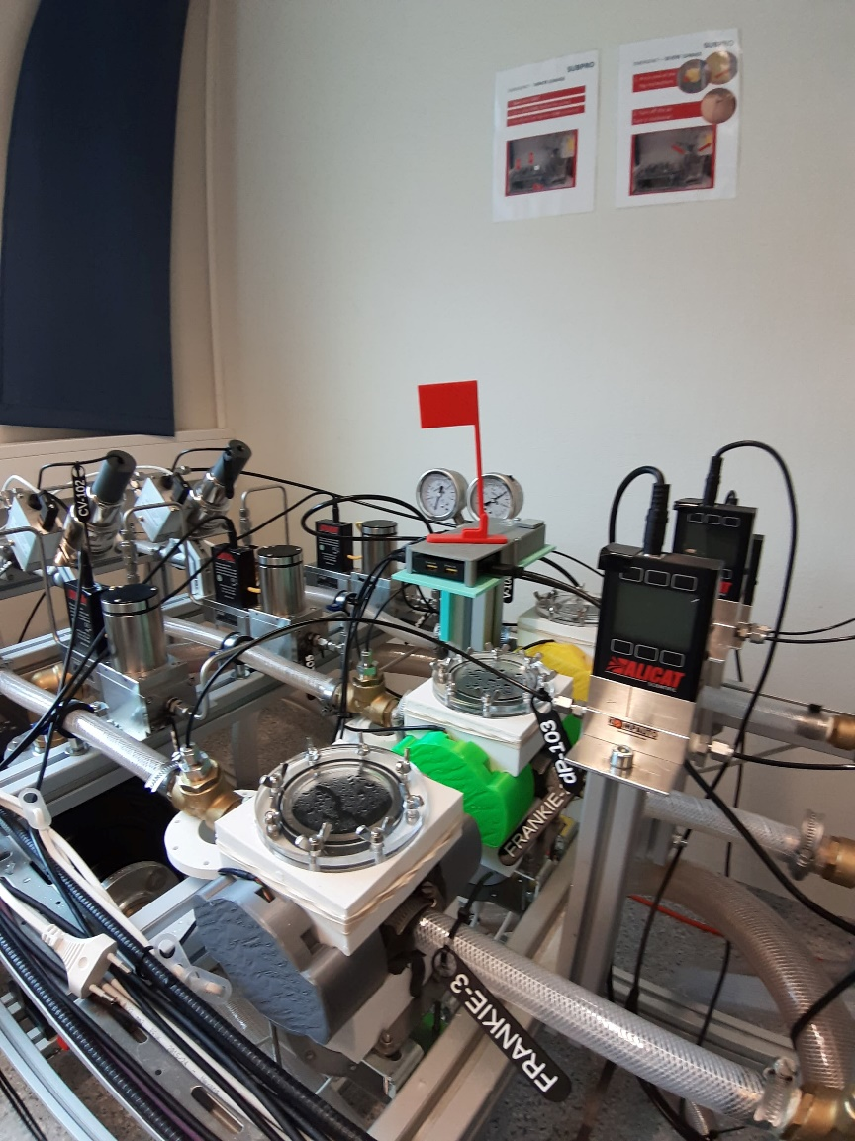

The rig is under maintenance. So do not run it!

1. It is possible that due to printing imprecisions the covers do not fit perfectly. In that case, use the workaround files (also attached or here). They were designed to fill in the gap between the two side covers. You can adjust their size in the 3D model if necessary.
2. You can also print probe with different geometries. In the folder, you can find a different probe, which is simply a square without internal parts.